Exercise 4-10: A graphical approach was used to solve the following LP model in problem.
Maximize profit+ $4x +$5y
Subject to the constraints
5x+2y 40
3x +6y 30
x 7
2x – y 3
x, y 0
Use the graphical solution to answer the following questions. Each question is independent of the others.
Determine if (and how) the following changes would affect the optimal solution values and or profit.
(a) A technical breakthrough raises the profit per unit of Y to $10.
(b) The profit per unit of X decreases to only $2.
(c) The first constraint changes to 5x + 2y ≤ 54.

Exercise 4-12: A graphical approach was used to solove the following LP model in problem 2-15:
Maximize profit = $4X + $3Y
Subject to constraints
2X + 4Y ≤ 72
3X + 6Y ≥ 27
-3X +10Y ≥ 0
X, Y ≥ 0
Use the graphical solution to answer the following question. Each question is independent of the others. Determine if (and how) the following changes would affect the optimal solution values and/or profit
- The profit per unit of X decreases to $1
- The first constraint changes to 2X + 4Y ≤ 80
- The third constraint changes to -3X +10Y ≤ 0

Exercise 4-14: Consider the MSA marketing research example discussed in Section 3.3 (page 74) of Chapter 3. Use the sensitivity report for this LP model (shown in screenshot 4-7 on page 150) to answer the following questions. Each question is independent of the other.
(a) What is the maximum unit cost that will make it worthwhile to include in the survey persons 30 years of age or younger who live in a border state?
(b) What is the impact if MSA wants to increase the sample size to 3,000?
(c) What is the impact if MSA insists on including people 31-50 years of age who do not live in a border state?
(d) What is the impact if we can reduce the minimum 30 or younger persons required to 900 provided that we raise the persons 31-50 years of age to 650?
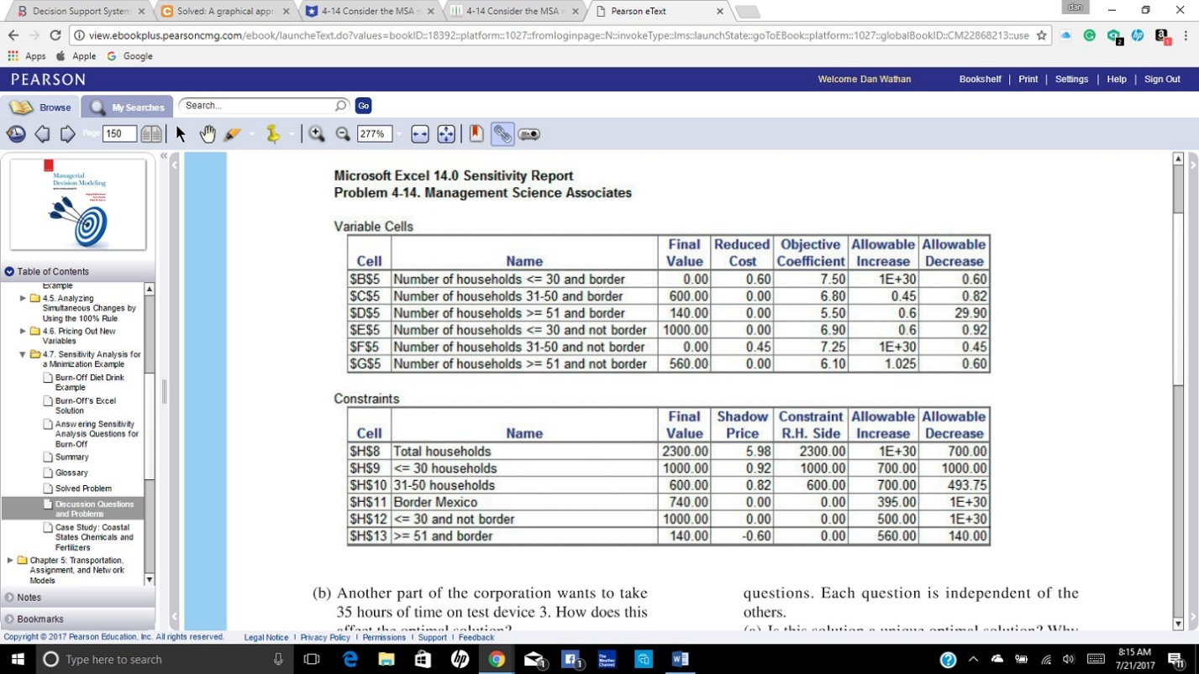

Exercise 4-20: consider the following LP problem, in which X and Y denote the number of units of products X and Y to produce, respectively:
Maximize = $4X+ $5Y

subject to constraints
X+2Y ≤ 10 (labor variable, in hours)
6X+6Y ≤ 36 (material available, in pounds)
8X+4Y ≤ 40 (storage available, in square feet)
X,Y ≥ 0 (nonnegativity)

calculate and explain what happens to the optimal solution for each of the following situations.

A. you acquire 2 additional pounds of material
B. you acquire 1.5 additional hours of labor
C. you give up 1 hour of labor and get 1.5 pounds of material
D. the profit contributions for both products x and y are changed to $4.75 each
E. you decide to introduce a new product that has a profit contribution of $2. each unit of this product will use 1 hour of labor and 1 pound of material and 2 square feet of storage space.
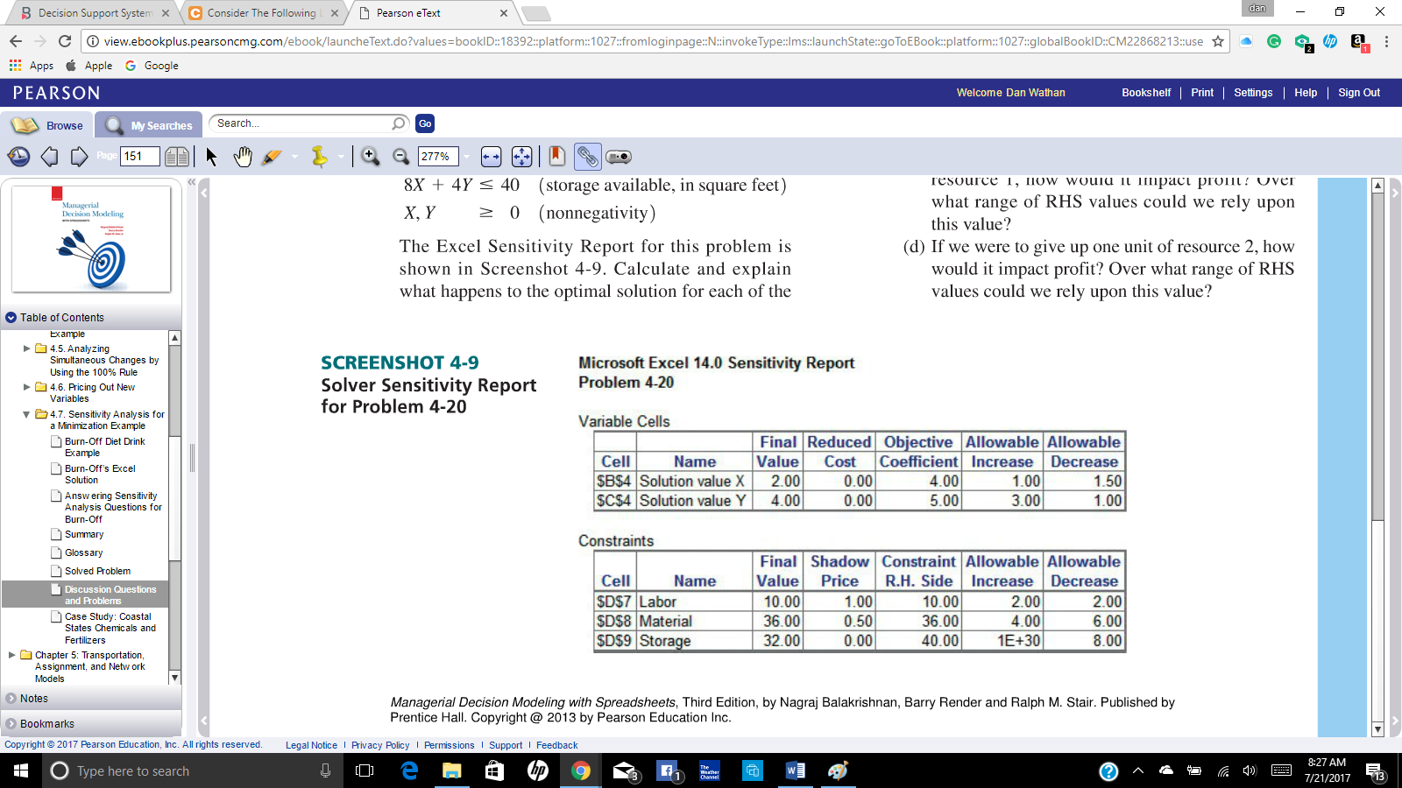

Exercise 4-22: The Good-to-Go Suitcase Company makes three kinds of suitcases:
(1) Standard, (2) Deluxe, and (3) Luxury styles.
Each suitcase goes through four production stages: (1) cutting and coloring, (2) assembly, (3) finishing, and (4) quality and packaging.
The total number of hours available in each of these departments is 630, 600, 708, and 135, respectively.
Each Standard suitcase requires 0.7 hours of cut- ting and coloring, 0.5 hours of assembly, 1 hour of finishing, and 0.1 hours of quality and packaging.
The corresponding numbers for each Deluxe suit-case are 1 hour, 5/6 hours, 2/3 hours, and 0.25 hours, respectively.
Likewise, the corresponding numbers for each Luxury suitcase are 1 hour, 2/3 hours, 0.9 hours, and 0.4 hours, respectively.
The sales revenue for each type of suitcase is as follows: Standard $36.05, Deluxe $39.50, and Luxury $43.30. The material costs are Standard $6.25, Deluxe $7.50, and Luxury $8.50. The hourly cost of labor for each department is cutting and coloring $10, assembly $6, finishing $9, and quality and packaging $8.

The Excel layout and LP Sensitivity Report of Good-to-Go
problem are shown in Screenshots 4-11A and 4-11B, respectively. Each of the following questions is independent of the others.
(a) What is the optimal production plan? Which of the resources are scarce?
(b) Suppose Good-to-Go is considering including a polishing process, the cost of which would be added directly to the price. Each Standard suit- case would require 10 minutes of time in this treatment, each Deluxe suitcase would need 15 minutes, and each Luxury suitcase would need 20 minutes. Would the current production plan change as a result of this additional process if 170 hours of polishing time were available? Explain your answer.
(c) Now consider the addition of a waterproofing process where each Standard suitcase would use 1 hour of time in the process, each Deluxe suitcase would need 1.5 hours, and each Luxury suitcase would require 1.75 hours. Would this change the production plan if 900 hours were available? Why or why not?

